**Practical-1**

**Aim**: **Write a C program to print all alphabets from a to z. using do-while loop**

**Program**:

#include<stdio.h>

#include<conio.h>

#define p printf

#define s scanf

main()

{

char a;

clrscr();

a='a';

do

{

printf("%c\t",a);

a++;

}while(a<='z');

getch();

}

**Output**: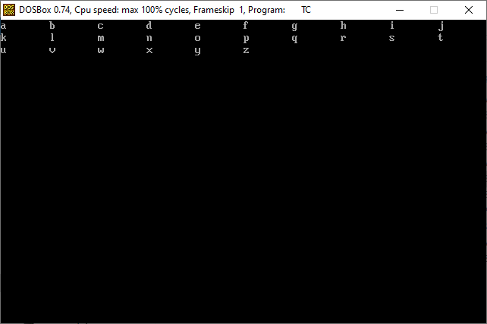

**Practical-2**

**Aim:Write a C program to count a number of digits in a number**.

**Program**:

#include<stdio.h>

#include<conio.h>

#define p printf

#define s scanf

main()

{

long int num,count=0;

clrscr();

printf("Enter any number:");

scanf("%ld",&num);

while(num>0)

{

num=num/10;

count=count+1;

}

printf("Digits of is %ld ",count);

getch();

}

**Output**: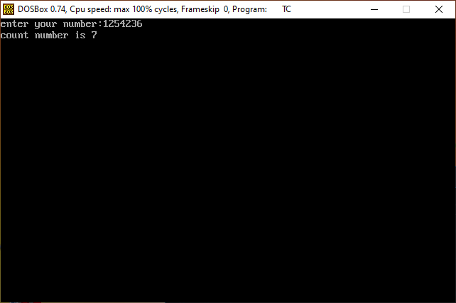

**Practical-3**

**Aim:Write a C program to find the sum of the first and last digit of a number.**

**Program**:

#include<stdio.h>

#include<conio.h>

#define p printf

#define s scanf

main()

{

long int num,first,last,sum=0;

clrscr();

p("enter your number:");

s("%ld",&num);

last=num%10;

first=num;

while(num>=10)

{

num=num/10;

}

first=num;

sum=first+last;

p("sum=%ld",sum);

getch();

}

**Output**:

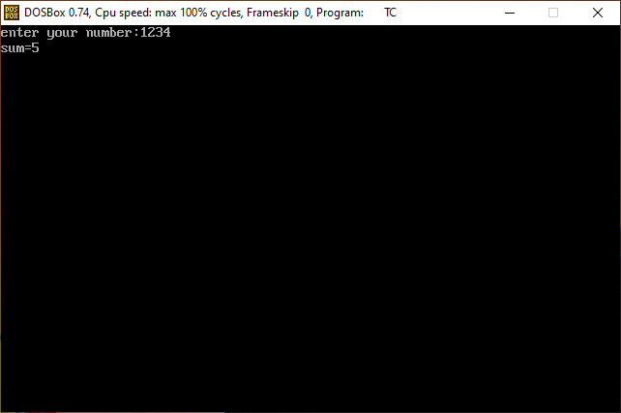

**Practical-4**

**Aim: Write C program to enter a number and print its reverse & check whether num is palindrome or not?**

**Program**:

#include<stdio.h>

#include<conio.h>

#define p printf

#define s scanf

main()

{

int num,reverse=0,remainder,temp;

clrscr();

p("Enter any number\n");

s("%d",&num);

temp=num;

while(num>0)

{

remainder=num%10;

reverse=reverse*10+remainder;

num/=10;

}

p("\n\nGiven number is %d\n",temp);

p("\n\nreverse number is %d\n",reverse);

if(temp==reverse)

{

p("\n\nthis is pallindrone\n");

}

else

{

p("\n\nthis is not pallindrone\n");

}

getch();

}

**Output**:

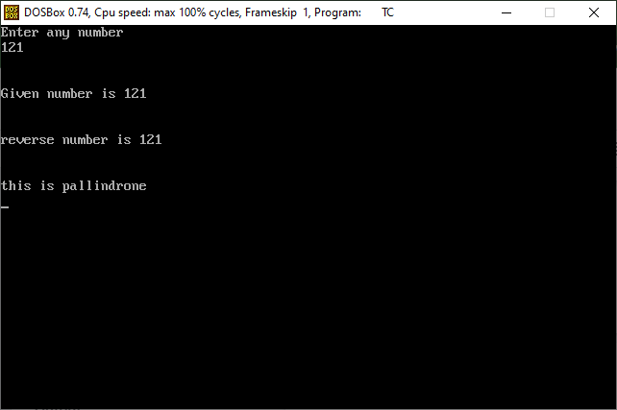

**Practical-5**

**Aim:Write C program print out Fibonacci series. (0,1,1,2,3,5,8…)**

**Program**:

#include<stdio.h>

#include<conio.h>

main()

{

int num,i,first=0,second=1,next=0,count;

clrscr();

printf("Enter any numbers");

scanf("%d",&num);

printf("\nfibonacci series :%d %d ",first,second);

count=2;

while(count<num)

{

next=first+second;

first=second;

second=next;

++count;

printf("%d\t",next);

}

getch();

}

**Output**:

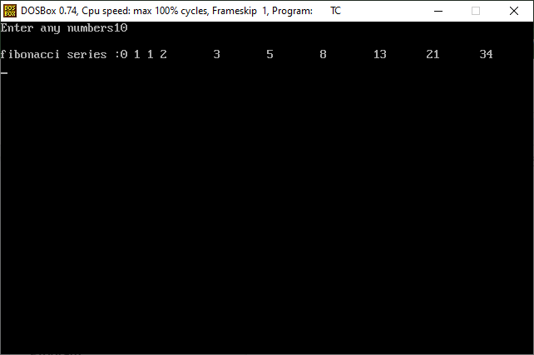

**Practical-6**

**Aim:Program Check whether num is prime or not.**

**Program**:

#include<stdio.h>

#include<conio.h>

#define p printf

#define s scanf

main()

{

int num,count=0,i;

clrscr();

p("enter your number:");

s("%d",&num);

for(i=2; i<num; i++)

{

if(num%i==0)

count++;

}

if(count!=0)

{

p("this is not a prime number");

}

else

{

p("this is prime number");

}

getch();

}

**Output**: